Settings for Cedalo

In the Battery Emulator V10 or later
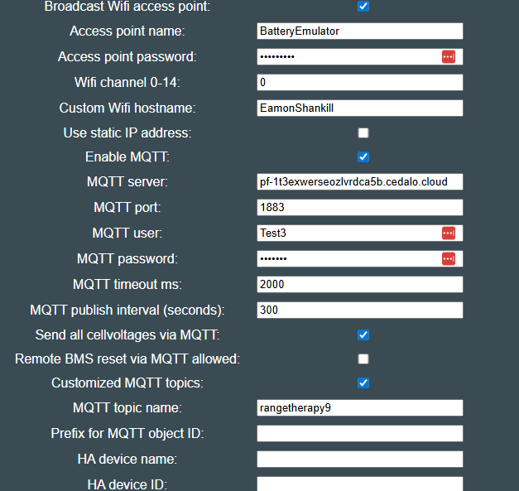
Client ID is the Access point name + ‘-‘ + the Custom Wifi Name
So in this case “BatteryEmulatorClient-EamonShankill”
This will be needed when setting up the client in the Cedalo UI
MQTT Server is pf-1t3exwerseozlvrdca5b.cedalo.cloud
MQTT port is 1883
MQTT user and password are set in the Cedalo UI

In the Cedalo user interface
Login at https://platform.cedalo.cloud/auth/login
Go to Range Therapy Project
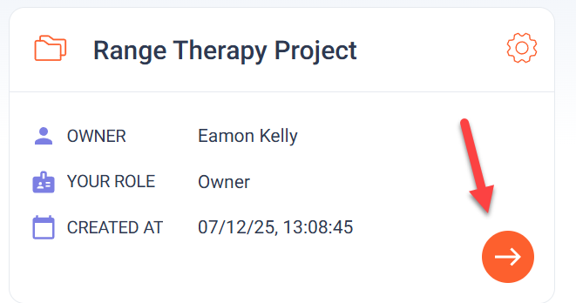
Click on Brokers 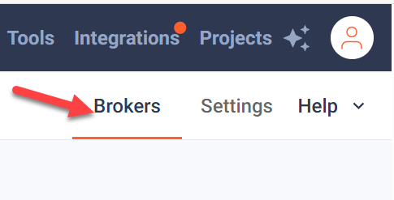
Go to the Pro Mosquitto M Plan 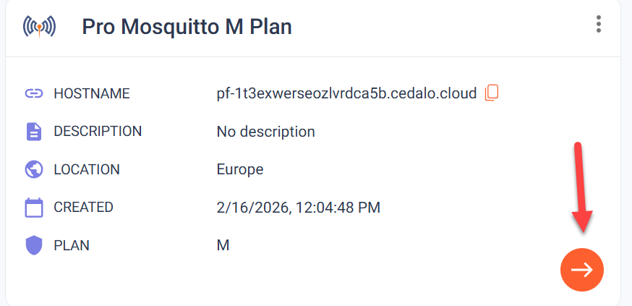
Click on Client Accounts and then ADD CLIENT 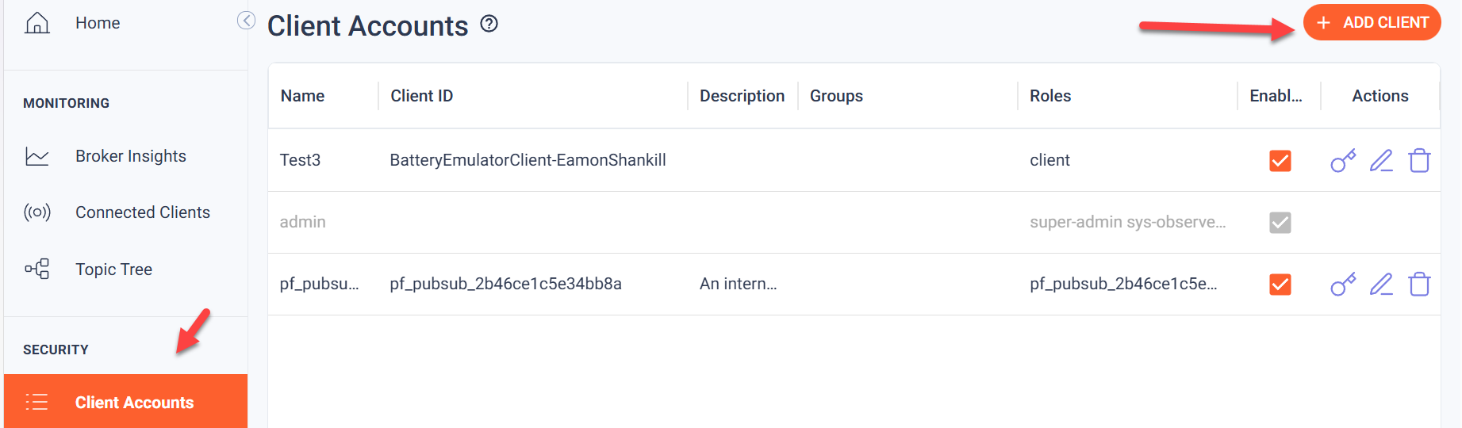
Click on Add Client 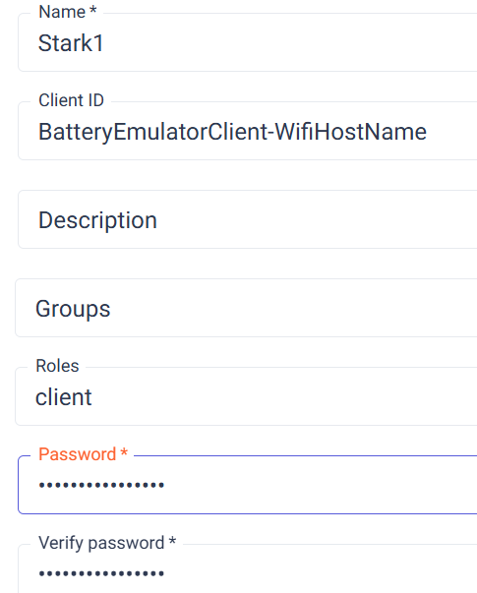
These settings map to the battery emulator settings page as follows:
Name is the MQTT user
Client ID is the BatteryEmulatorClient followed by a minus followed by the Custom Wifi hostname
Password is the MQTT password
Select “client” for the Role
Click ADD CLIENT
If all went well, a green tick will appear on the Home, Connected Clients page
